**PROJECT NAME : AGRO BOT UNIVERSAL AI BASED AGRICULTURAL ASSISTANT**

**2nd Milestone Project Report**

**(PASUNURI POOJA-** [**poojareddypasunuri@gmail.com**](mailto:poojareddypasunuri@gmail.com) **MALLA REDDY ENGINEERING COLLEGE FOR WOMEN)**

**GITHUB LINK:** [**https://github.com/Pasunuri-Pooja/agri-chat-bot.git**](https://github.com/Pasunuri-Pooja/agri-chat-bot.git)

**Project Type:** Full-Stack Web Application

**Technologies Used:**

* **Backend:** Python, Flask, Flask-SQLAlchemy
* **AI/ML:** DeepSeek (OpenRouter API), Google Translator, LangDetect

Other Libraries: Requests, dotenv, werkzeug.security

* **Database:** SQLite
* **Frontend:** HTML, CSS, jQuery, Bootstrap (optional)

**ProjectDescription:**  
Agro Chatbot is an AI-driven agriculture assistant designed to help farmers and agriculture students interactively. It provides guidance on crops, soil, pests, fertilizers, harvest, and more. The system supports multiple languages and keeps a history of user interactions for both users and administrators.

**ChatBot User Interface:**

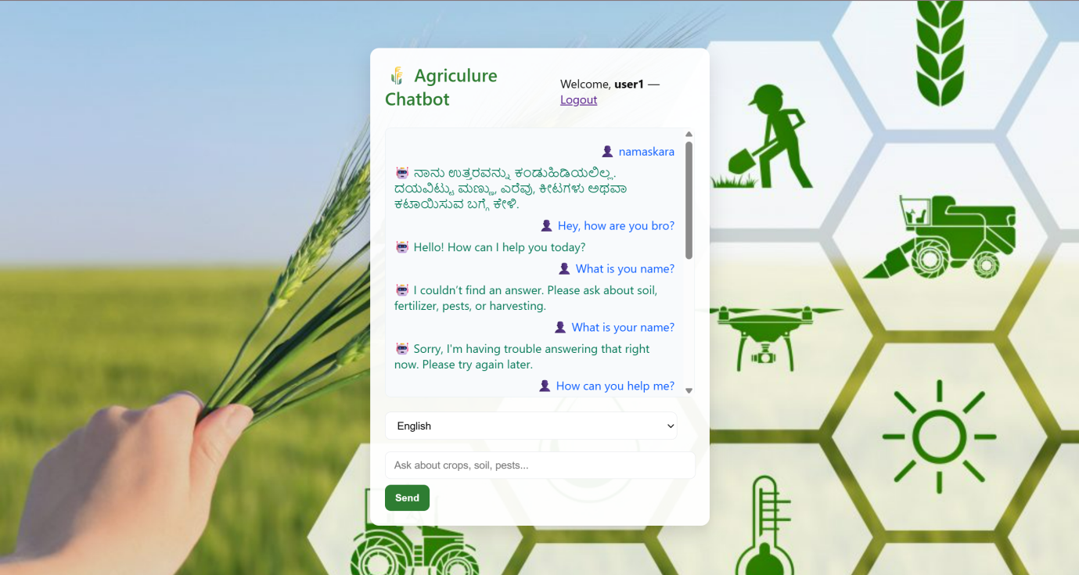

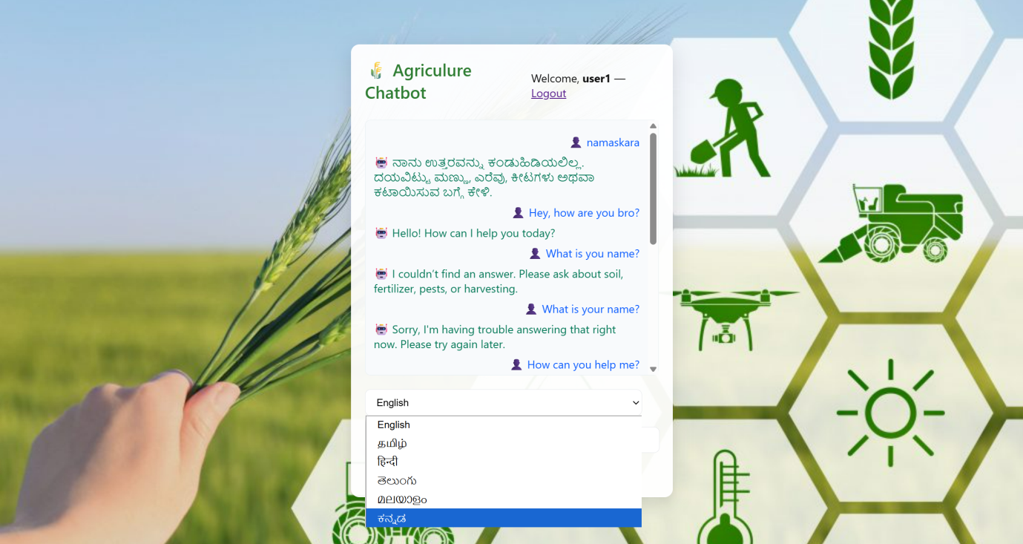

1. **User Authentication & Registration**
   * Users can register and login securely.
   * Passwords are hashed using werkzeug.security.

**Register Page:**

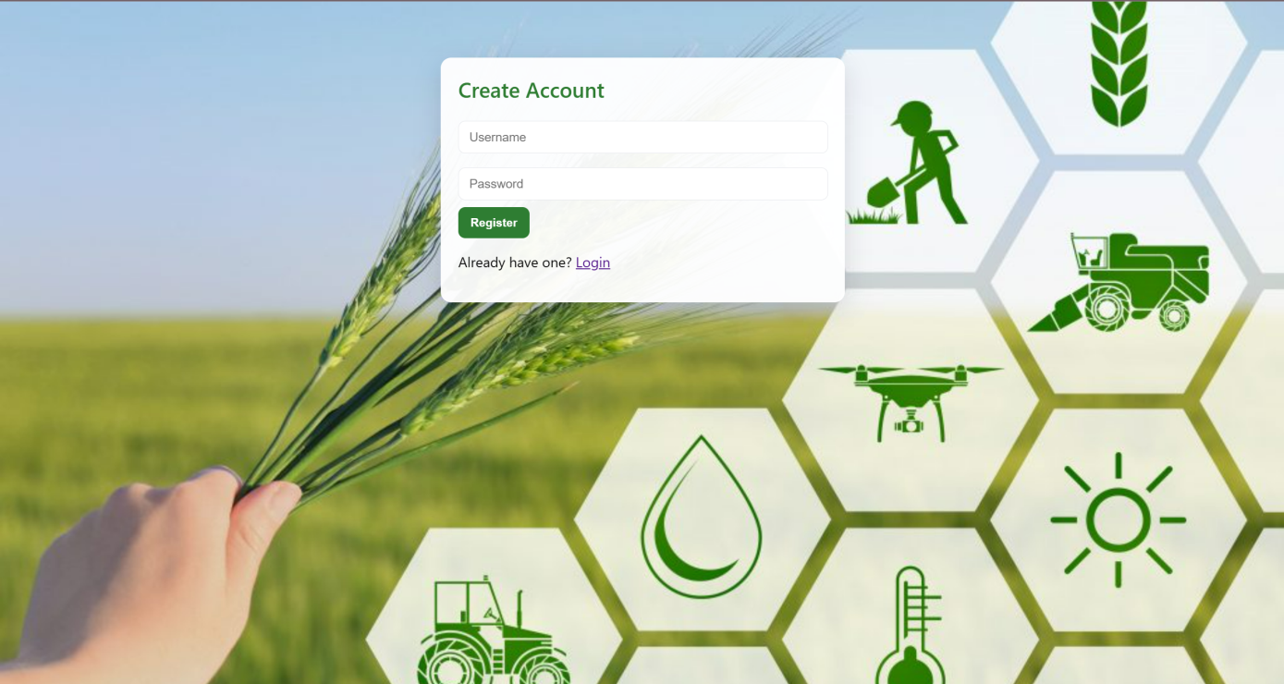

**Login Page:**

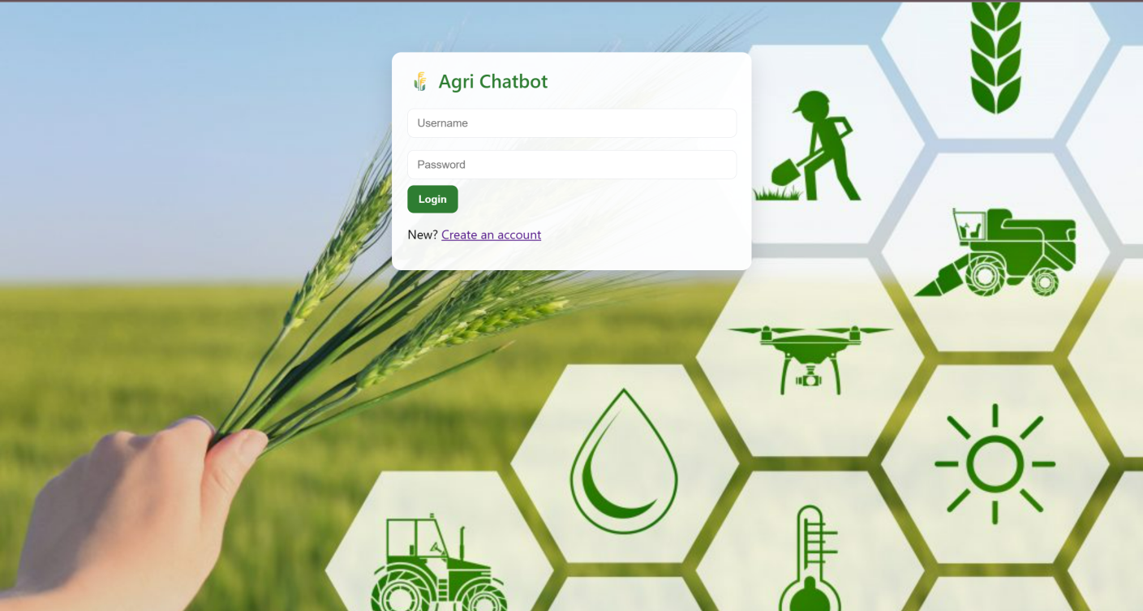

**Admin Login Page:**

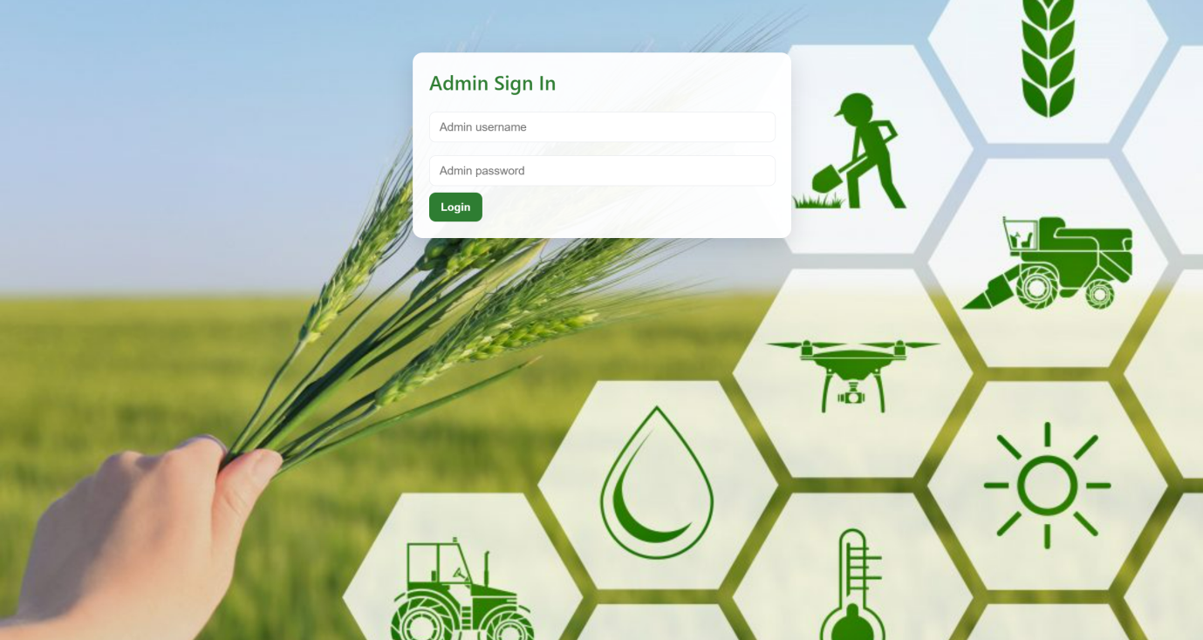

1. **Admin Dashboard**
   * Admin can login using a separate credential (admin/admin123 by default).
   * Admin can view chat history, search messages, download CSV, and clear chat history.

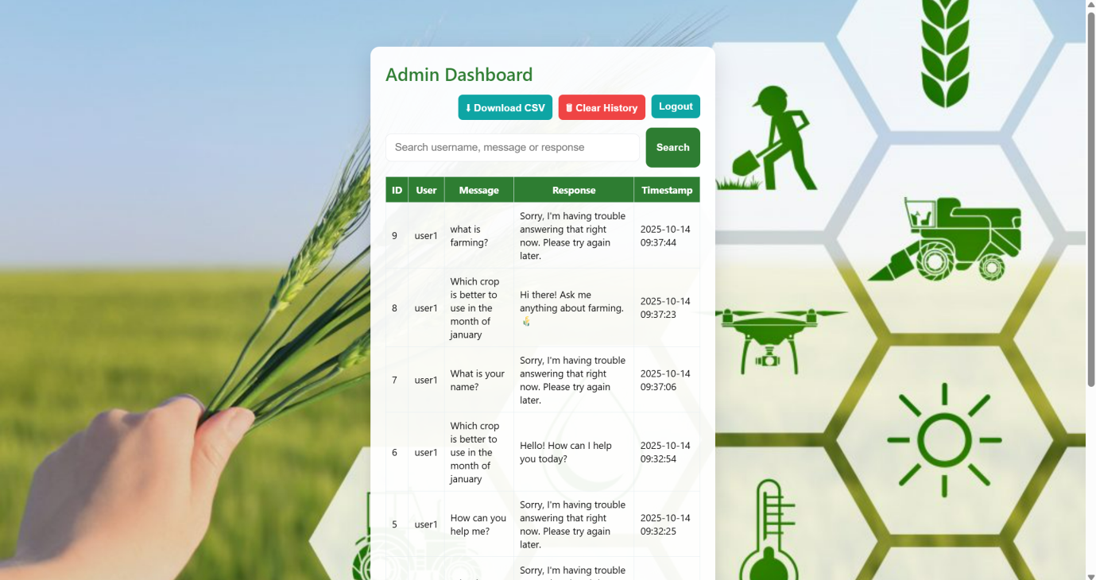

1. **Persistent Chat History**
   * User queries and AI responses are stored in SQLite database using SQL Alchemy ORM.
   * Admin can analyze all interactions.

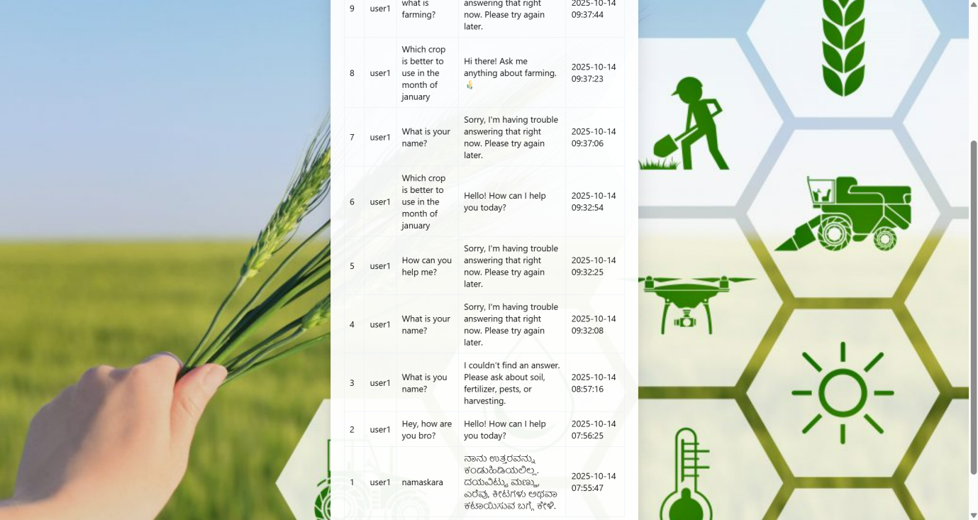

1. **Fallback & Greetings Handling**
   * Handles greetings (hello, hi) and farewells (bye, thanks) automatically with predefined responses.
   * Fallback message is used if AI cannot generate a response.

**Project Structure**

Agro Chat Bot/

│

├── app.py

├── database.py

├── chatbot_model.py

├── agro_queries.py

├── translator_util.py

├── .env

├── static/

│ └── style.css

└── templates/

├── index.html

├── register.html

├── chat.html

├── admin_login.html

└── admin_dashboard.html

**Detailed Feature Explanation: Multi-Language AI Chatbot**

**Objective:**  
Allow users to ask questions about agriculture in any supported language and receive answers in the same or a selected language.

**How It Works :**

1. **User Input (Frontend):**
   * The user chooses a language and types a question in the chat window.
   * The message is sent to the Flask backend using jQuery AJAX through the /chat route.
2. **Backend Processing (chatbot_model.py):**
   * **Language Detection:** The system automatically detects the language of the user’s input.
   * **Greeting & Farewell Handling:** Simple greetings or goodbyes are handled directly.
   * **Offline Knowledge Base:** If the question matches known topics like soil, pests, or fertilizers, a predefined answer is returned.
   * **AI Model (DeepSeek):** If no match is found, the question is sent to the DeepSeek AI model for a smart response.
   * **Translation:** The response is translated into the user’s selected language using Google Translator if needed.
3. **Response Saving & Display:**
   * The user’s question and chatbot’s reply are saved in the database.
   * The chatbot’s answer is then sent back as JSON and shown on the chat screen.

**Outcome:**  
Users can easily interact with the chatbot in their chosen language, and the system intelligently provides accurate, agriculture-related information based on their queries.

**Admin Features:**

* **View Chat History:** Search conversations by username, user message, or bot reply.
* **Download CSV:** Export chat records for further review or data analysis.
* **Clear History:** Delete all stored chat logs from the database.
* **Authentication:** Only authorized admin users can access these management options.

**Conclusion:**  
This project showcases a real-time, multilingual AI chatbot built with a strong backend, database, and admin panel. It effectively integrates:

* Predefined agricultural knowledge base
* Dynamic AI-generated responses using DeepSeek
* Multi-language translation via Google Translator
* Chat history storage using SQLite and SQLAlchemy
* Admin controls for monitoring and maintenance

**Future Enhancements:**

* Adding new information about crops, fertilizers, and farming methods
* Integrating advanced AI models like LLaMA 3 or Mixtral for faster, smarter replies
* Introducing voice-based input and output for a more interactive experience

**Additional Note:**  
The chatbot uses the **OpenRouter.ai API (DeepSeek Model V3)** to generate responses. It’s free to use for unlimited queries, though it may have some delay and performance limitations.  
  
Model Respond in English Language:  
  
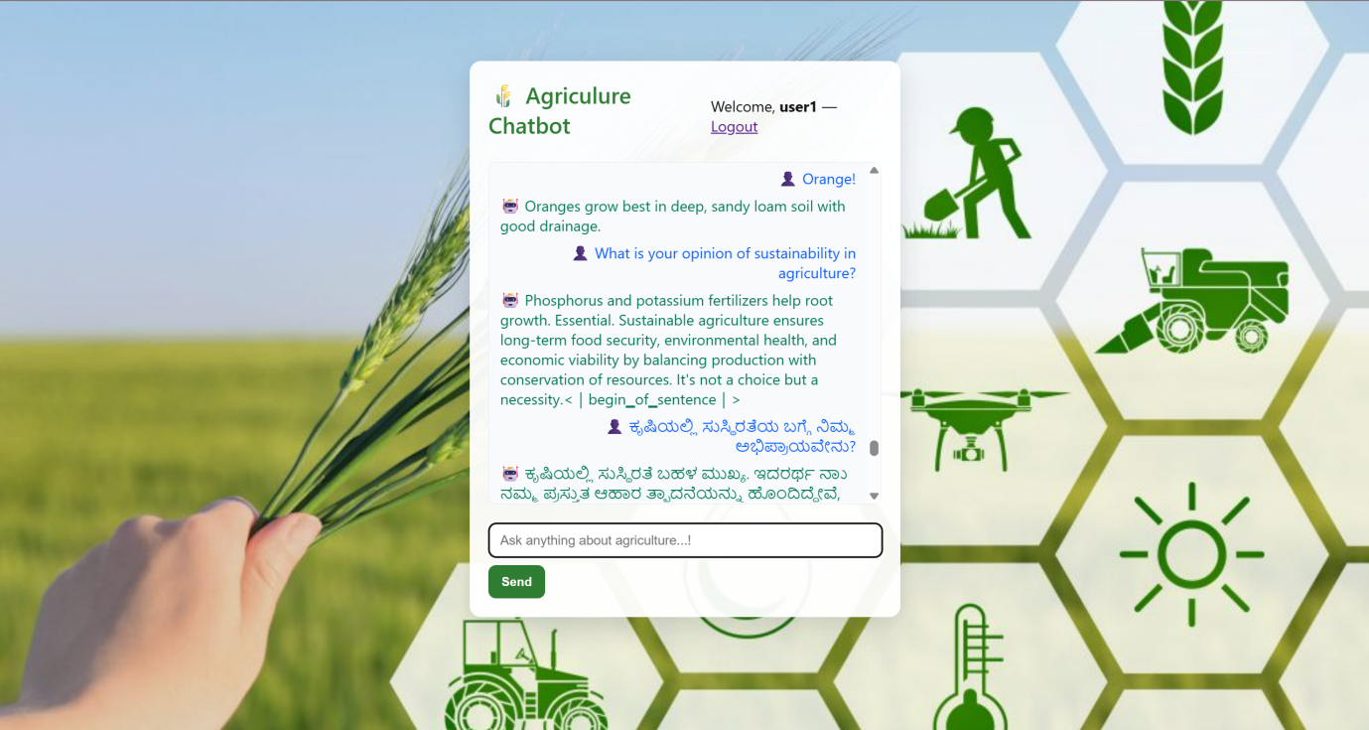

Model Respond in Hindi Language:

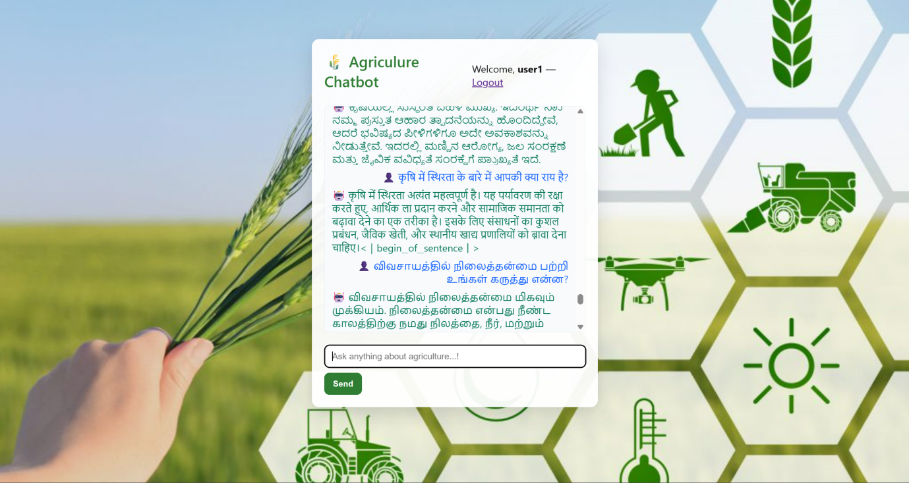

Model Respondin Telugu Language:

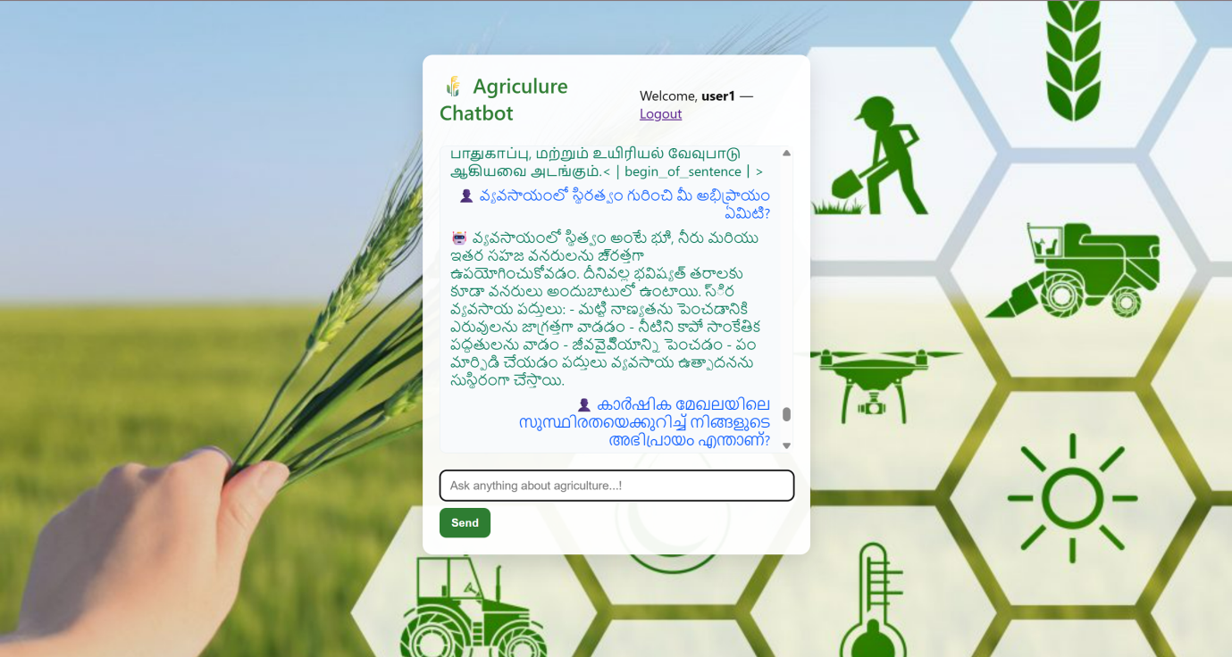

Model respond in offline mode:

